Population health analysis

1. Children Diesease and treatment data analysis

Having state wise data of total cases of Acute Respiratory Infection, Diarrhoea, Fever and the counts of cases where treatment was administered, we can analyse the current situation of health services and how much awareness is there for the health services.

* 1. Acute Respiratory infection analysis
     1. First line graph shows Rural, Urban and Total infection counts
     2. Second line graph shows Rural, Urban and Total counts of cases where people sought treatment
     3. Area graph showing state wise data for in how many cases treatment was administered

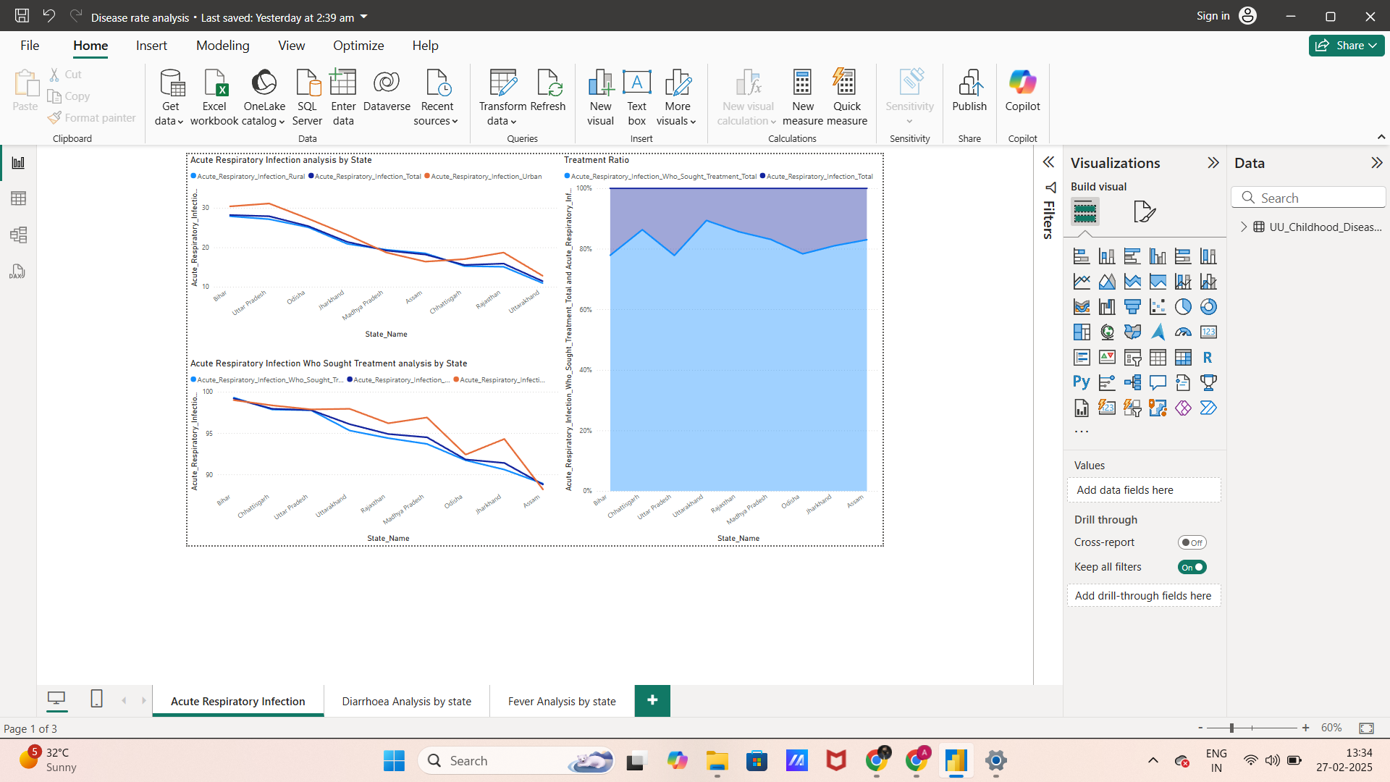

* 1. Diarrhoea Analysis
     1. First line graph shows Rural, Urban and Total infection counts
     2. Second line graph shows Rural, Urban and Total counts of cases where people sought treatment
     3. Area graph showing state wise data for in how many cases treatment was administered

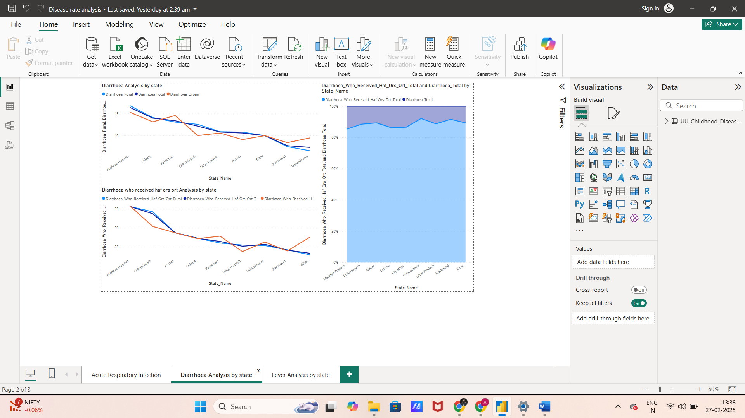

* 1. Fever Analysis
     1. First line graph shows Rural, Urban and Total infection counts
     2. Second line graph shows Rural, Urban and Total counts of cases where people sought treatment
     3. Area graph showing state wise data for in how many cases treatment was administered

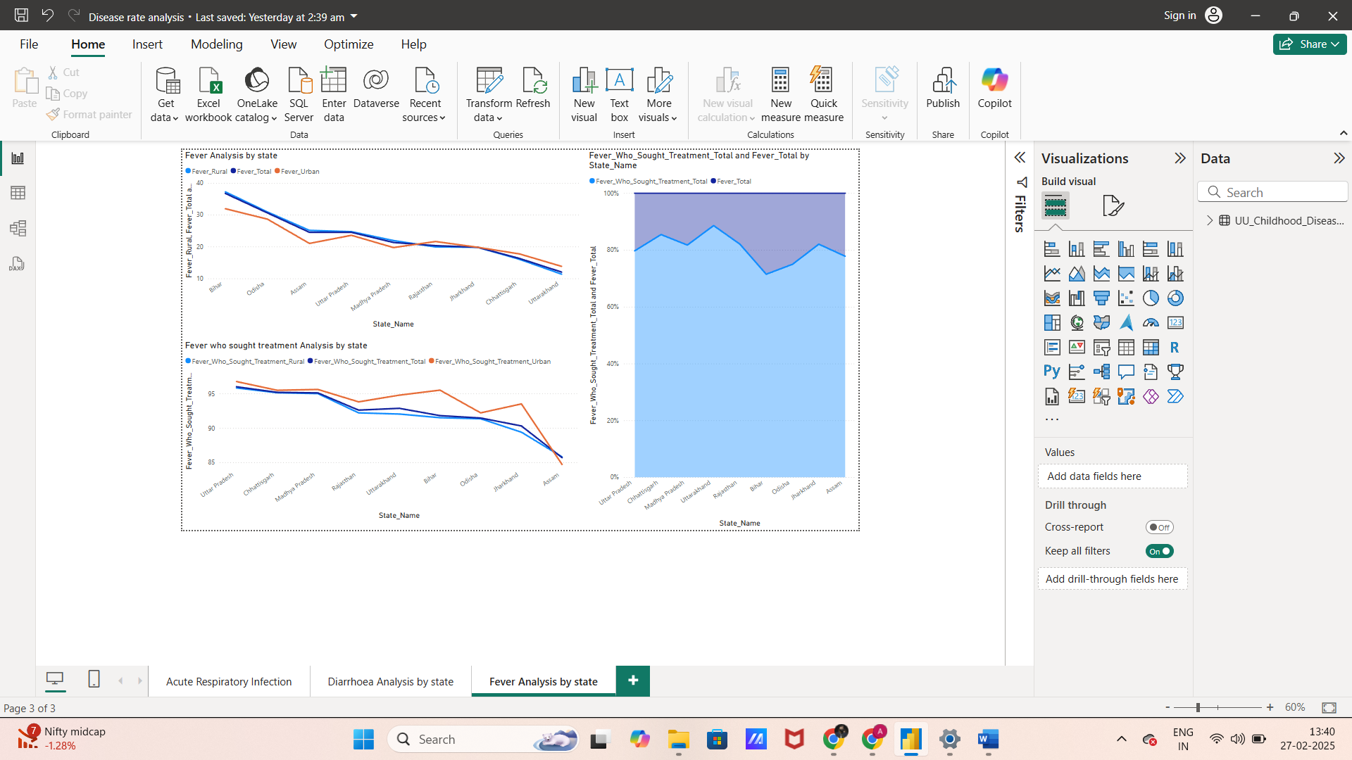

From the data we can Bihar, Uttar Pradesh and Madhya Pradesh having worst awareness about health services in current times.

Madhya Pradesh also has most Diarrhoea cases which is result of unhygienic eating habits caused by bad water and food quality.